DNS(Domain Name System):

- DNS acts as a translator between Human and Computer, because humans remembers the URLs and computers understands IP addresses.

- DNS maintains a table in which the URLs are mapped with the IP addresses.
For example,
URL = google.com
IP Address = 72.125.68.102

- So, when user types www.google.com, DNS converts it to its corresponding IP address using that table.

DNS Servers:

- Servers are the computers who store the HTML pages, images, audios, videos, etc.

- So, the DNS servers are the servers that work together to provide IP addresses of the requested website/URL to the web browsers.

Types of DNS Servers:

- DNS Recursive Resolvers/ DNS Resolvers
- Root Name Server
- TLD (Top Level Domain) Name Server
- Authoritative Name Server

Details here about DNS and its types: https://www.youtube.com/watch?v=JkEYOt08-rU

Classful Addressing: https://www.youtube.com/watch?v=1Kwbo23RLGQ
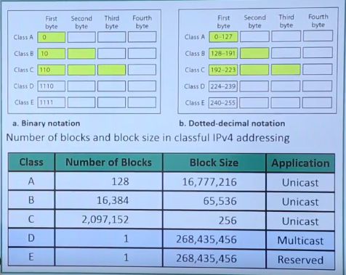

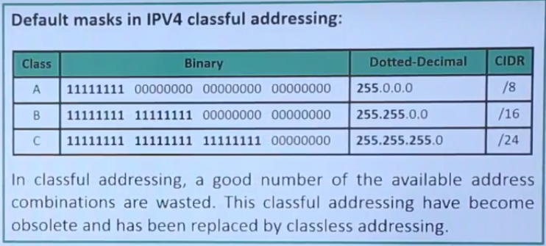

Classless Addressing: https://www.youtube.com/watch?v=Tqm8Mhb4L50

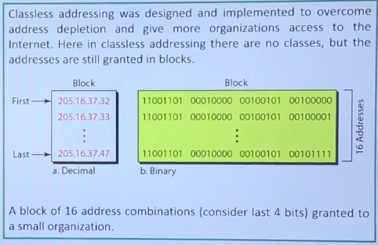

Casting:
https://www.geeksforgeeks.org/computer-network-difference-unicast-broadcast-multicast/

Subnetting: https://www.youtube.com/watch?v=ev9oYEkL-do

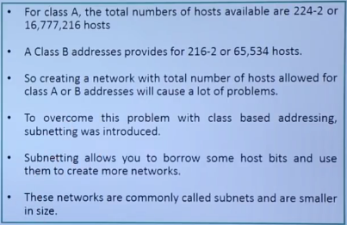

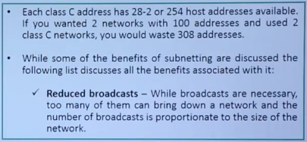

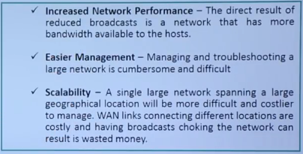

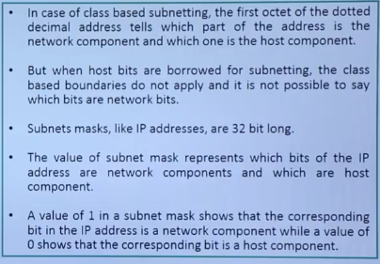

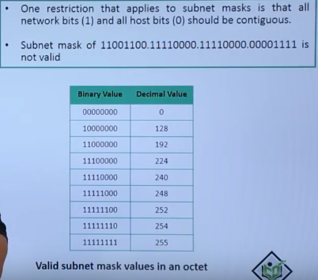

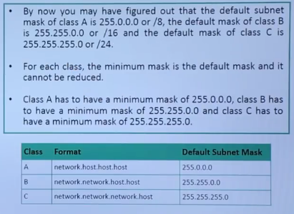

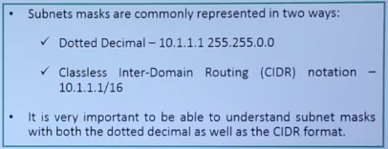

Basic Ports: https://www.utilizewindows.com/list-of-common-network-port-numbers/

